1.Student Attendence system
Create a simple cloud software application for Students Attendance System using any Cloud Service Provider to demonstrate SaaS include the necessary fields such as name of the students, course, present , Absent, course attendance, OD request, grade, attendance percentage, etc
Aim:
To create a simple cloud-based Students Attendance System using Zoho Creator to demonstrate Software as a Service (SaaS) for managing student attendance records online.
Software Required:
- Zoho creator
Procedure :
- Login to Zoho Creator and create a new application named Students Attendance System.
- Create a Student Details Form with fields like Student Name, Roll Number, Course, and Email.
- Create an Attendance Form with fields such as Date, Student Name (lookup), Course, and Status (Present/Absent).
- Add fields for OD Request (On Duty) using a dropdown (Yes/No).
- Include fields for Total Classes, Classes Attended, and Attendance Percentage.
- Add a Grade field based on attendance percentage (e.g., A, B, C).
- Generate reports to view attendance records, student-wise performance, and percentage.
- Deploy the application on cloud and provide access to users via link (SaaS model).

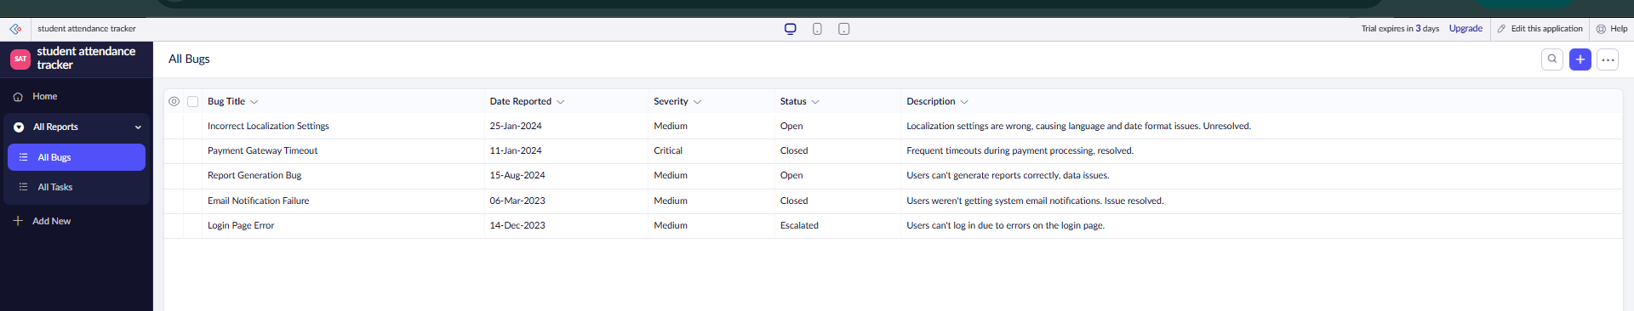
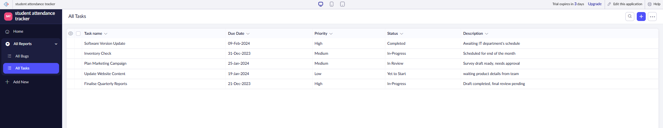

Result :
The Students Attendance System was successfully developed using Zoho Creator.
It demonstrates SaaS by enabling online attendance tracking, OD management, and performance monitoring.

2.Flight Reservation System
Create a simple cloud software application for Flight Reservation System using any Cloud Service Provider to demonstrate SaaS.
Aim:
To create a simple cloud-based Flight Reservation System using Zoho Creator to demonstrate the concept of Software as a Service (SaaS), enabling users to book flights, manage reservations, and view booking details online.
Software Required:
- Zoho creator
Procedure :
- Login to Zoho Creator with your account.
- Create a new application named Flight Reservation System.
- Design a Passenger Details form with basic fields like name, age, and contact.
- Create a Flight Details form with flight number, source, destination, and timing.
- Build a Reservation form linking passenger and flight details using lookup fields.
- Add required input fields such as seat number, class type, and payment status.
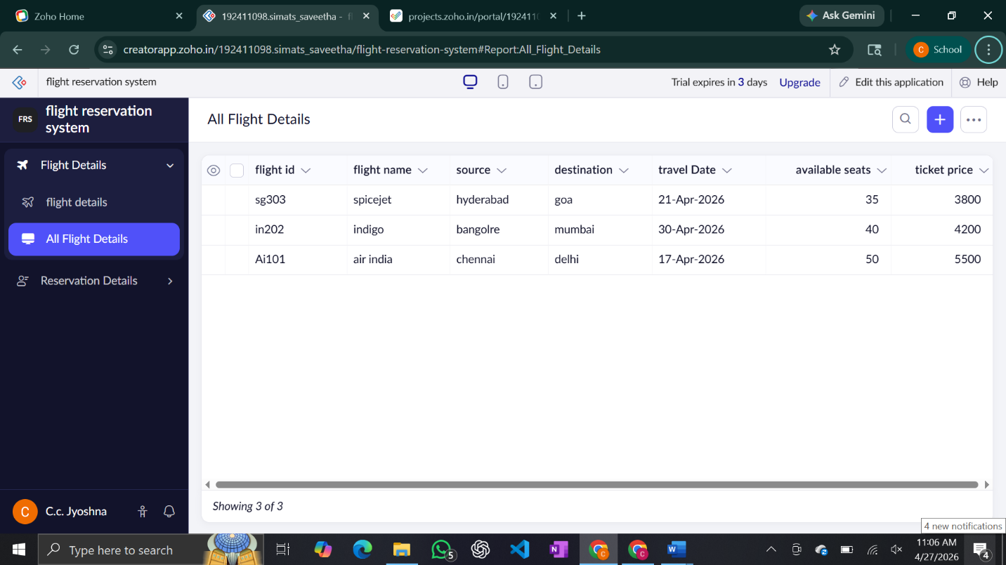
- Generate reports to display passenger list, flight schedule, and bookings.
- Deploy the application on cloud and share access with users.

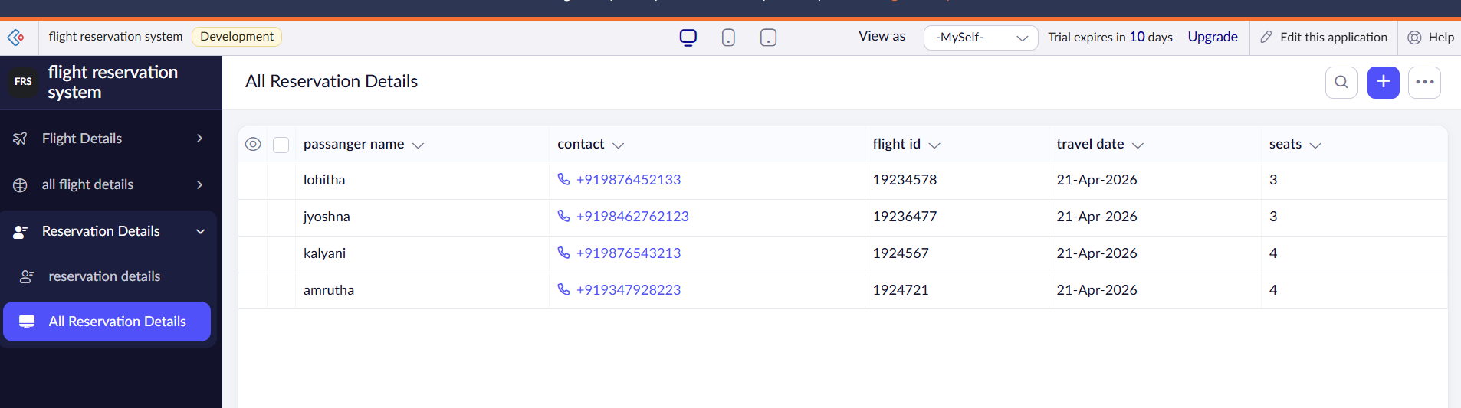

3. Chennai property buying

Create a simple cloud software application for Property Buying &amp; Rental process (In Chennai city) using any Cloud Service Provider to demonstrate SaaS.

Aim:
To develop a cloud-based Property Buying & Rental System for Chennai using Zoho Creator and demonstrate the concept of Software as a Service (SaaS) for managing property listings and customer bookings online.
Software Required:
- Zoho creator
Procedure :
- Login to Zoho Creator and create a new application named Property Management System.
- Create an Owner Details Form with fields like Owner Name, Contact Number, and Email.
- Create a Property Details Form including Property Type (House/Flat), Location (Chennai areas), Price, Rent, and Availability.
- Add a Customer Details Form with Customer Name, Phone, Email, and Requirement (Buy/Rent).
- Create a Booking/Enquiry Form linking customer and property using lookup fields.
- Include fields such as Booking Date, Rental Duration, and Payment Status.
- Generate reports to view available properties, bookings, and customer enquiries.
- Deploy the application on cloud and share access via link to demonstrate SaaS.

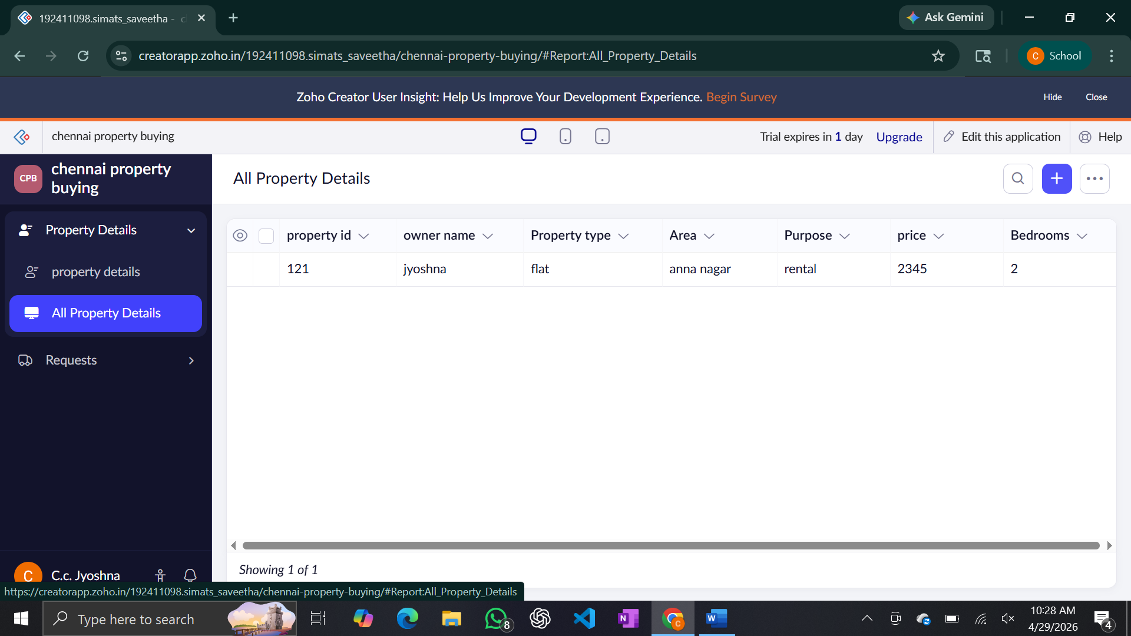

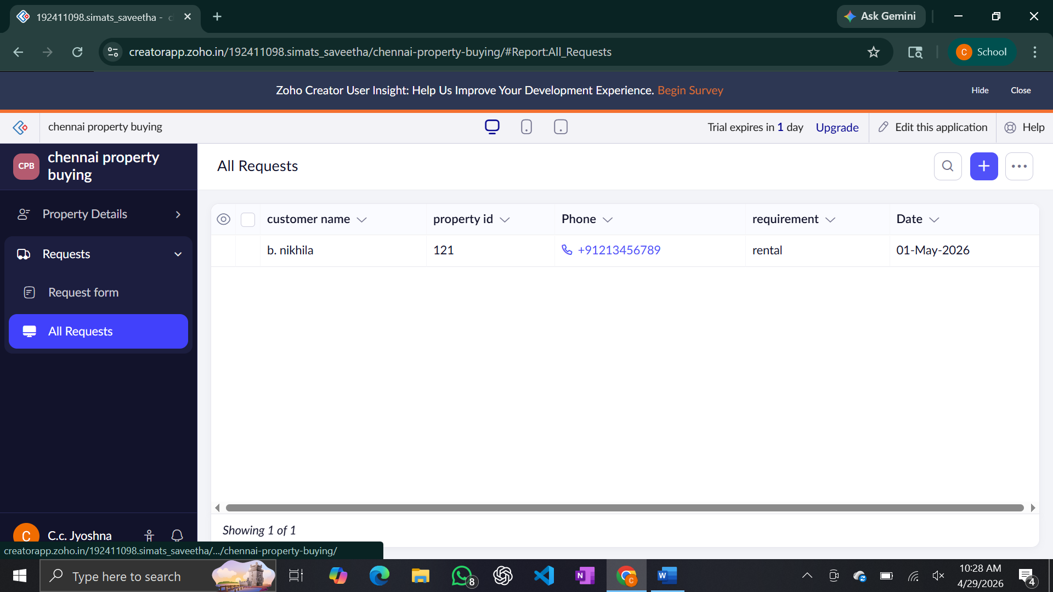

Result :
The Property Buying & Rental System was successfully developed using Zoho Creator.
It demonstrates SaaS by enabling online property listing, booking, and rental management.

4. car booking reservation system

Aim:
To create a cloud-based Car Booking Reservation System using Zoho Creator and demonstrate the concept of Software as a Service (SaaS) for booking cars online.
Software Required:
- Zoho creator
Procedure :
- Login to Zoho Creator and create a new application named Car Booking System.
- Create a Customer Details Form with fields like Name, Phone Number, and Email.
- Create a Car Details Form including Car Name, Model, Type, and Price per Day.
- Add a Booking Form linking customer and car details using lookup fields.
- Include fields such as Booking Date, Pickup Date, Return Date, and Location.
- Add Total Amount field based on number of days and price.
- Create reports to display available cars, booking details, and customer records.
- Deploy the application on cloud and share access to users (SaaS model).

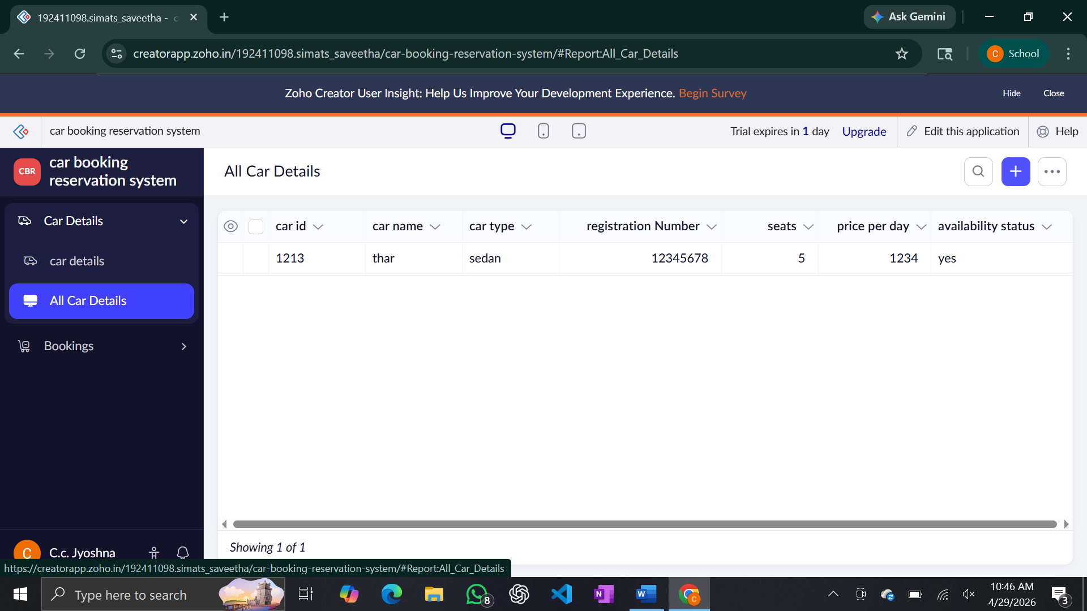

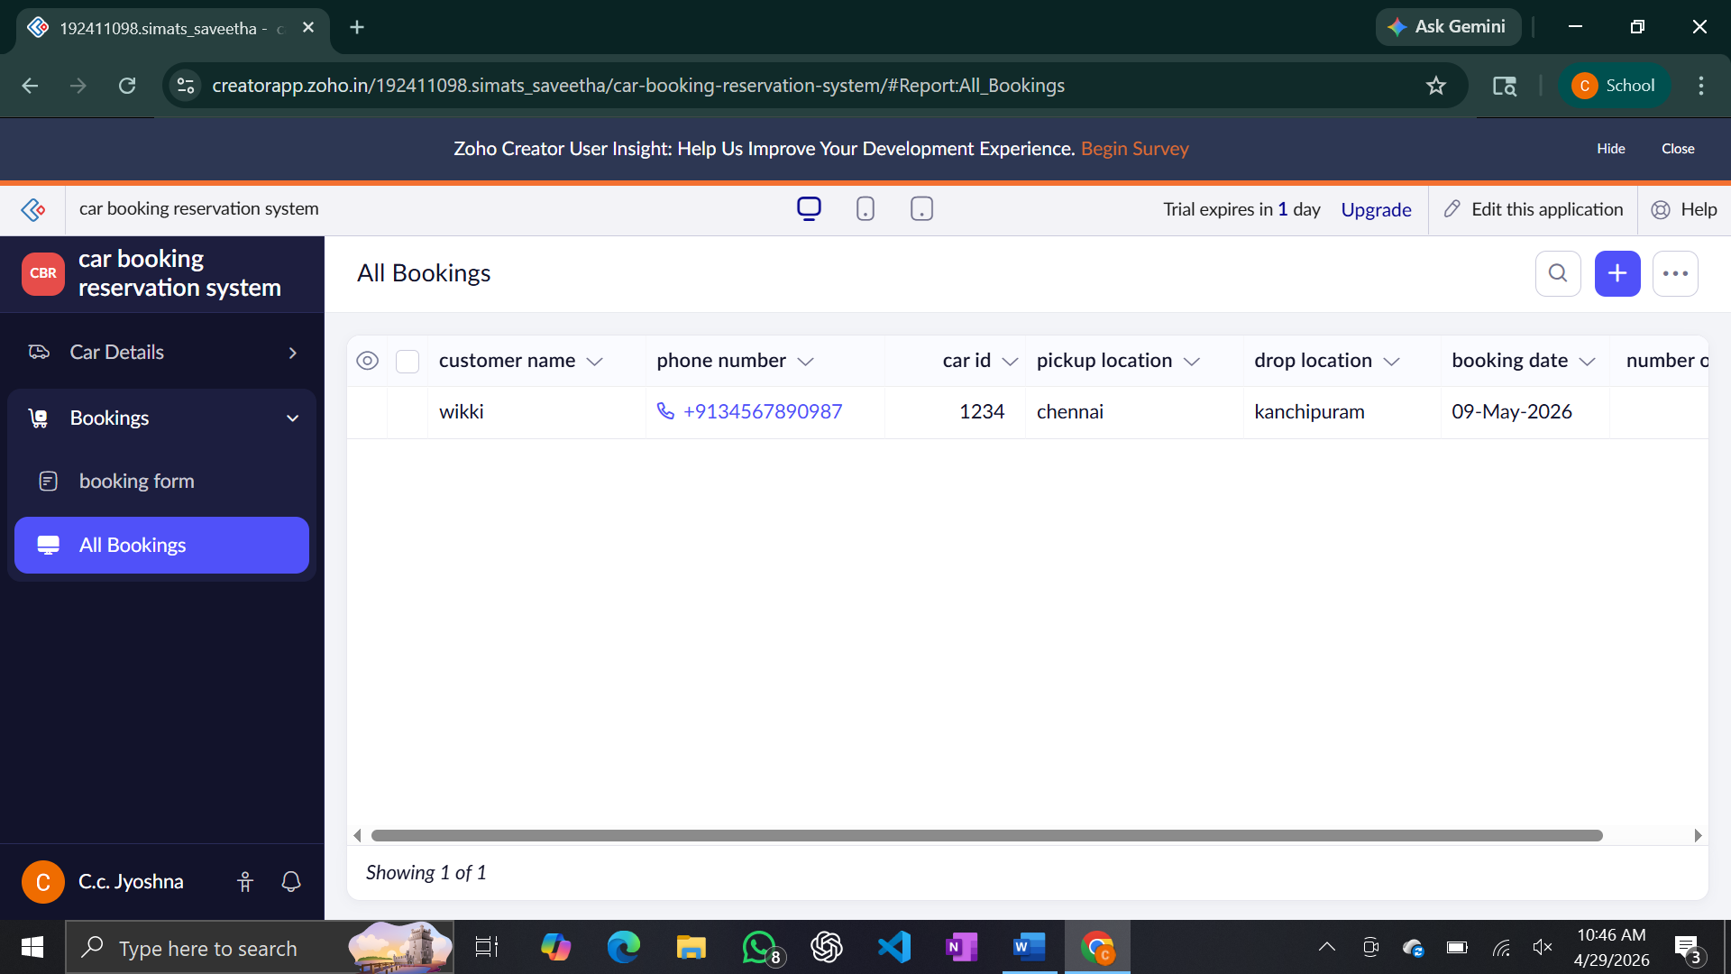

Result :
The Car Booking Reservation System was successfully developed using Zoho Creator.
It demonstrates SaaS by enabling online car booking, availability tracking, and payment management.

5.HOSPITAL MANAGEMENT SYSTEM

Aim:
To create a cloud-based Hospital Management System using Zoho Creator and demonstrate the concept of Software as a Service (SaaS) for managing hospital records online.
Software Required:
- Zoho creator
Procedure :
- Login to Zoho Creator and create a new application named Hospital Management System.
- Create a Patient Details Form with fields like Name, Age, Gender, Phone, and Address.
- Create a Doctor Details Form including Doctor Name, Specialization, and Contact.
- Create an Appointment Form linking patient and doctor using lookup fields.
- Add fields such as Appointment Date, Time, and Consultation Type.
- Create a Medical Record Form to store diagnosis, treatment, and prescription.
- Generate reports to view patient records, appointments, and doctor schedules.
- Deploy the application on cloud and provide access to users (SaaS model).

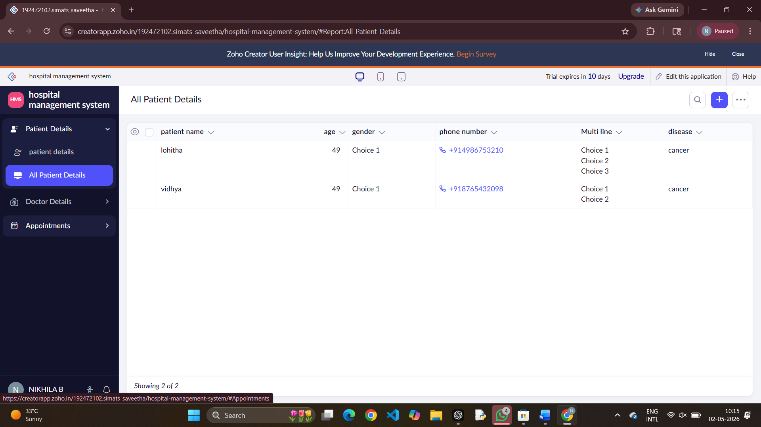

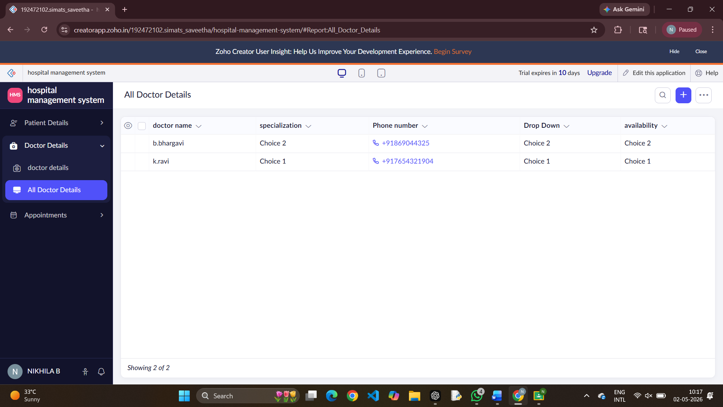

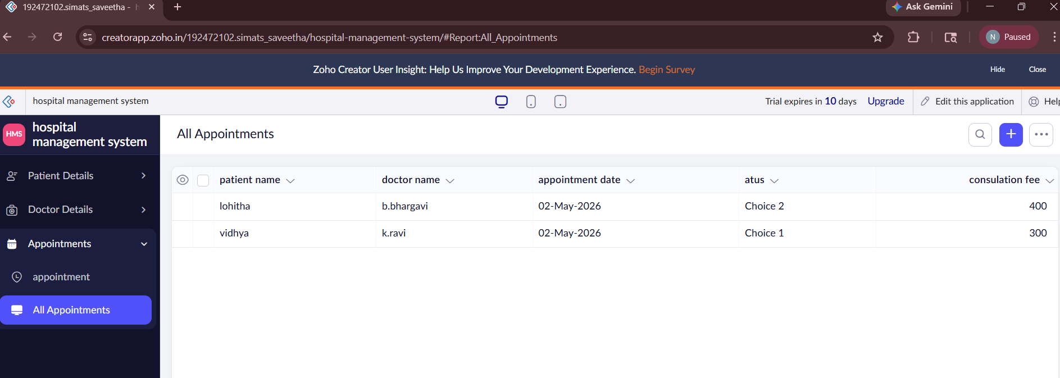
Result :
The Hospital Management System was successfully developed using Zoho Creator.
It demonstrates SaaS by enabling online patient management, appointment scheduling, and record maintenance.

6. LIBRARY MANGEMENT SYSTEM
Aim:
To create a cloud-based Library Management System using Zoho Creator and demonstrate the concept of Software as a Service (SaaS) for managing library records online.
Software Required:
- Zoho creator
Procedure :
- Login to Zoho Creator and create a new application named Library Management System.
- Create a Student Details Form with fields like Student Name, Roll Number, and Course.
- Create a Book Details Form including Book Name, Author, Category, and Availability.
- Create an Issue/Return Form linking student and book using lookup fields.
- Add fields such as Issue Date, Return Date, and Fine Amount.
- Include a field for Book Status (Issued/Available).
- Generate reports to view issued books, returned books, and student records.
- Deploy the application on cloud and share access with users (SaaS model).
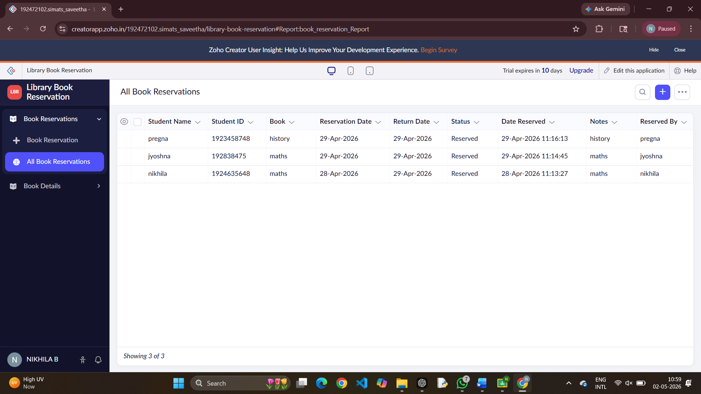
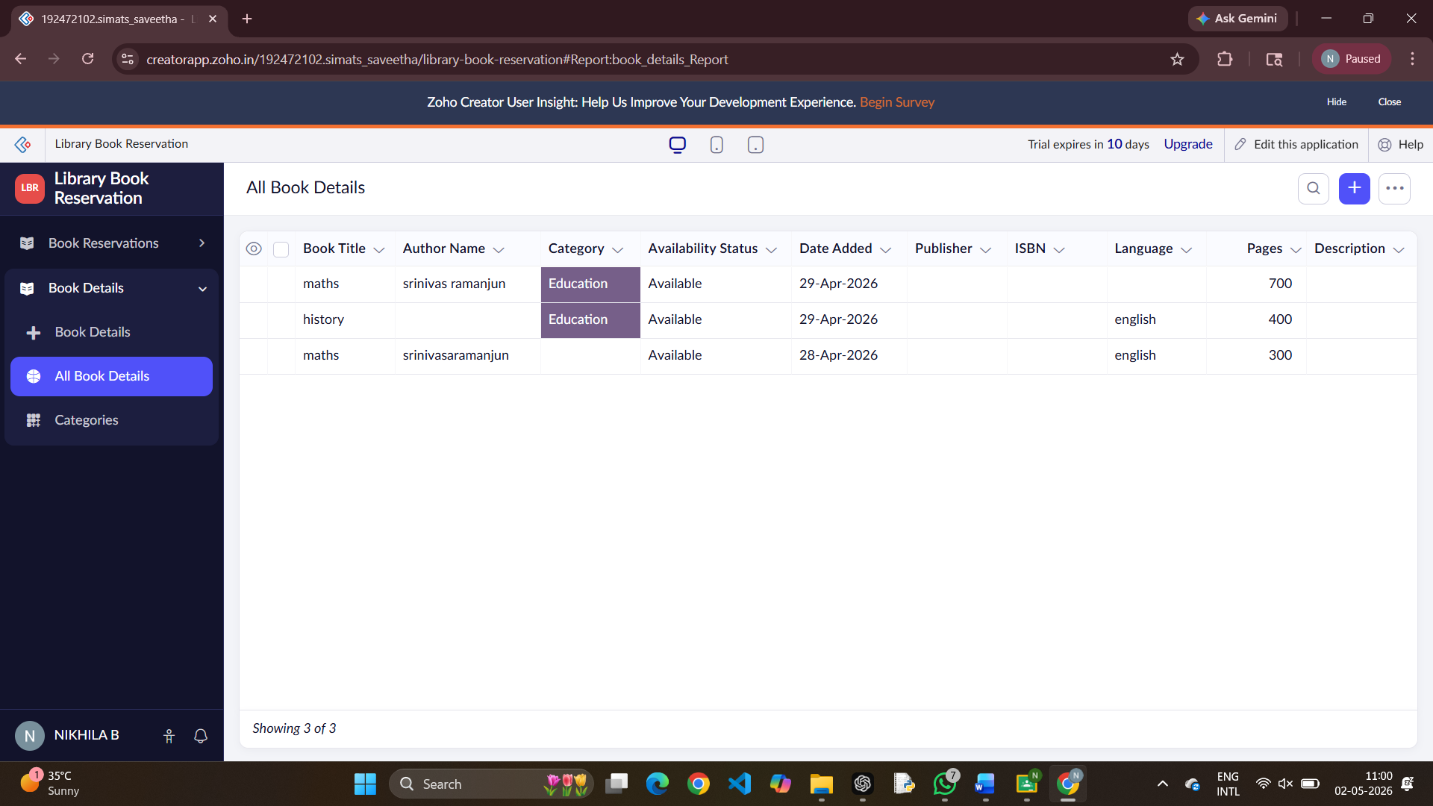

Result :
The Library Management System was successfully developed using Zoho Creator.
It demonstrates SaaS by enabling online book management, issue/return tracking, and record maintenance.

